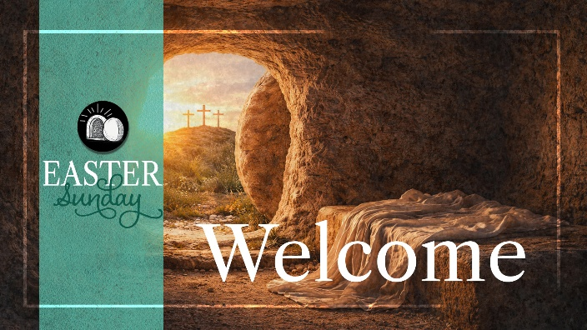

April 5, 2026

Hymn # 217 “Christ the Lord Is Risen Today”
Responsive Reading # 214
Prayer of Invocation
Hymn # 222 “Easter Song”
Worship in Song
Offering
Heather Arlin and Jenefer White
"Beneath the Cross of Jesus" *

Message – Evidences that Point to the Truth
Hymn # 216 “Christ Arose”
Benediction

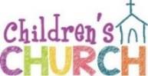

* After this song, young children are dismissed for Children’s Church downstairs. Nursery and toddler rooms are open throughout worship.

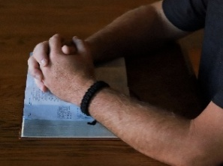
Tuesday Morning Prayer Everyone is invited Tuesdays at 9:30 a.m. to a time of prayer in the church library. Giving thanks, and praying for needs in our families, missionaries, our communities and worldwide.


Youth Group Teens, 7th grade and up, are invited 6:30 - 8:30 p.m. Tuesday evenings for dinner, studying God’s Word, worship and games! Teens growing in their faith and reaching others in our community.
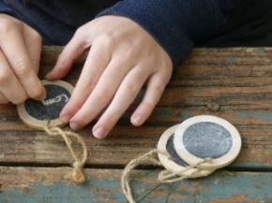
Keepers of TRUE Faith Pre-K thru 6th graders meet Wednesdays 6:30-8 PM thru the school year for games, crafts, snacks, and meeting new friends! This year we will be discovering God’s greatness and how we can serve Him.

NO Keepers on April 29th

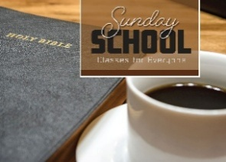
Sunday School for All! Everyone invited! 9:30 a.m. Sunday mornings. Children’s classes are downstairs, and Teens are in the loft.

Adults! Be part of great discussions and encouraging one another while learning more about God; back of the Sanctuary is studying Ezekial, and a second class, studying the book of John, meets in the library.


We’ll begin inside for a brief overview of what is in the night sky, consider some basic science of the celestial creation from a Christian perspective, and learn about some tools and equipment used to observe the skies. After it gets dark, we’ll have a couple of telescopes set up in the parking lot to view God’s breathtaking creativity.
Join us to see what God made in the sky!

Sunday, April 12th
(Rain date -19th)

If you own a telescope or binoculars, we encourage you to bring them. Questions? Ask Bob Hart (207) 351-5964


9 to Noon daily!
July 20th -24th
Vacation Bible School

Mark your calendars! Children from four years old through 6th grade are invited!–SonSurf Beach Bash will take kids to an unforgettable beach blast where they will come to know the living Jesus who said: “I am the way, the truth and the life; no one comes to the Father except through me.” (John 14:6).

The Christian Education Committee are planning a great Vacation Bible School for children in our church family and the community. Please let them know as soon if you can help with; teaching, crafts, snacks, help in a class room, decorating the church, and more!

Ginny (603) 781-8028, Laura (603) 957-1503,
Halie (207) 604-8071 or Katie (207) 939-0390

MONDAY -May 18th at 6:30 PM
Leaders Meeting for EVERYONE interested,
(or even thinking about helping!) in reaching children in our community with the Gospel through VBS.


Contact Kasey Hall (603) 970-1517 if you can help in Children’s Church or Nursery. If you are not sure what is involved… ask! Someone to teach each week is needed, along with helpers. Everyone working with children has a background check.


Books, devotionals, prayer requests, missionary updates and the Church Directory are on the table in the foyer. Please help yourself! The library has current books, fiction and nonfiction, and DVD’s to borrow, (directions for checking
out a book is on the desk.)

Trustees Meeting 6:30 p.m. April 14th



Keepers of TRUE Faith Races!
6:30 p.m. April 15th!
Everyone invited! Cheer on your favorite
car and enjoy ice cream sundaes!

Business Meeting April 19th
Following the Morning Worship

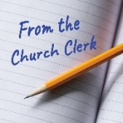
There is a notice in the glass bulletin board regarding proposed wording in the Church Constitution for Pastor’s vacation and Nominating Committee. These will be voted on in the April Business Meeting; April 19th following the Morning Worship.


Church Work Day! 8 AM April 25th

Minor repairs and yard clean up here at church! Bring gloves, rakes, wheel-barrows and wear old clothes!

Rain Date May 2nd



Church Directory app is Instant Church Directory (Green square with white church logo). Instruction for app is on the blue sheet of paper on the table in the foyer. The directories are used by new people trying to get to know each other, consider updating your photos! Only our church has access to the photo directory. Take a photo and text it to Susan at (603) 767-5015 or email to secretary@truememorial.org


Contact Alicia (603) 833-9356, if you would like to be on the mowing schedule.. Usually once every 5-6 weeks!

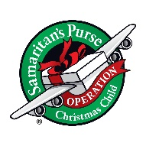
Operation Christmas Child Start collecting items now! You may assemble your own box or donate items and we will assemble! Include in boxes: toys, personal toiletry items, crayons, pencils, paper, socks and such. Add a “Wow” item! Something like a doll, beading kit, ball or other spectacular item. No war toys, candy or toothpaste.

The message of Salvation, in the child’s own language will be added. Boxes are delivered throughout the world to children in need. In many areas a weekly Bible study is then offered. Shoe boxes will be collected the beginning of November. For stories of how shoe boxes have impacted the lives of the children or for more information please visit : samaritanspurse.org

True Memorial Baptist Church

Touching Lives with Scripture

PO Box 1001, 21 Ten Rod Road,
Rochester, NH 03866-1001
truememorial.org (603) 332-3131





Easter Memorial Flowers
Given in Memory of…
Easter Memorial Flowers
Given in Memory of…

Barbara Jennings by Mark Jennings

John & Virginia Huckins by Janet Huckings Legere
Loved Ones by Bill & Julie McGowen

All Our Loved Ones by Peggy Cameron-Boyle

Micheal & Eleanor Pascucelli
by Chaz and Mary Beth Martinez

John & Virginia Huckins by Janet Huckings Legere

Parents: Sidney & Eleanor Littlefield.
Siblings: Diane, Gail Jennifern and Neil
by Dana, Brian & Donna Littlefield

Cynthia Sabatino by the Sabatino Family

Khishigjargal Dashdondov by the Sabatino Family

Javznmaa Dolgorjav by the Sabatino Family

Kathy Schmerhorn by The Lamirande Family

Lee White (Dad, Papa) by His Family

Our Loved Ones by Peggy Cameron-Boyle

Bob Arlin, Jr. by Heather Arlin

Robert & Jane Arlin by Heather Arlin

Ralph & Mable Lane
by Heather Arlin and Bruce & Dawn Vinciguerra

Loved Ones
by Diane Tebbetts, Deborah Roffo and Family

The Stanley Towle Family
by Bob & Suzanne Manson & Heather Bergeron

Nana Lindquist
by Bob & Suzanne Manson & Heather Bergeron

Nana Cabana
by Bob & Suzanne Manson & Heather Bergeron

Given in Memory of…

Thelma Tremblay by Lois Cahill

The Bergeron Family
by Bob & Suzanne Manson & Heather Bergeron

Bill Bryson by Sharon Bryson
Loved Ones by Susan & John Heimann

All Our Loved Ones by Peggy Cameron-Boyle

Wayne Wiggin by His Daughter

Ann Downs by Her Neice

Lea Castorl and Steven Pascucelli
by Chaz and Mary Beth Martinez

Loved Ones by David & Gail Malone

Wayne Wiggin by Dorothy Wiggin and Family

Lea Castorl and Steven Pascucelli
by Chaz and Mary Beth Martinez

Brad Wiggin by Pat and Family

Loved Ones by Mary Allyson
Pastor & Isabel Corbett by Carol Elliott

Loved Ones by Jim & Ginny Weeks

Loved Ones by Norman & Brenda Preston

Our Loved Ones by Peggy Cameron-Boyle

Thelma Tremblay by Lois Cahill
The MacKay’s and The Hilton’s by Family

Loved Ones by John & Marlene Allard

Vicky & Dick Day by Jim & Betsy Robertson

The Zinck Family by Ron & Jan Furbush

Giera & Furbush Families by Ron & Jan Furbush

