True Memorial Baptist Church

Touching Lives with Scripture



March 22, 2026

Worship in Song
Scripture Reading – 1 Corinthians 13:12-13
Prayer of Invocation
Worship in Song
Hymn # 549 “Face to Face”
Offering
Hymn # 542 When We All Get to Heaven”

Cindy Corson and Linda Anthony –
"Be Thou My Vision" *

Message – A Stranger in a Strange Land
Hymn “When We See Christ”
Benediction
Flowers this week are in

Loving Memory of Brad Wiggin

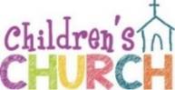

* After this song, young children are dismissed for Children’s Church downstairs. Nursery and toddler rooms are open throughout worship.
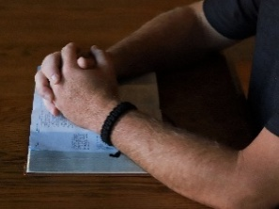
Tuesday Morning Prayer Everyone is invited Tuesdays at 9:30 a.m. to a time of prayer in the church library. Giving thanks, and praying for needs in our families, missionaries, our communities and worldwide.


Youth Group Teens, 7th grade and up, are invited 6:30 - 8:30 p.m. Tuesday evenings for dinner, studying God’s Word, worship and games! Teens growing in their faith and reaching others in our community.


Keepers of TRUE Faith Pre-K thru 6th graders meet Wednesdays 6:30-8 PM thru the school year for games, crafts, snacks, and meeting new friends! This year we will be discovering God’s greatness and how we can serve Him.

Sign up in the foyer to bring a snack for the children for just one week!

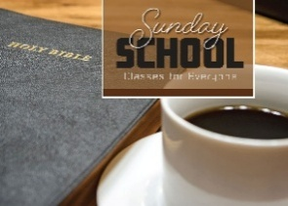
Sunday School for All! Everyone invited! 9:30 a.m. Sunday mornings. Children’s classes are downstairs, and Teens are in the loft.

Adults! Be part of great discussions and encouraging one another while learning more about God; back of the Sanctuary is studying Ezekial, and a second class, studying the book of John, meets in the library.


Books, devotionals, prayer requests, missionary updates and the Church Directory are on the table in the foyer. Please help yourself! The library has current books, fiction and nonfiction, and DVD’s to borrow, (directions for checking out a book is on the desk.)

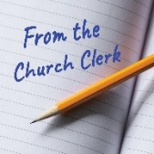
There is a notice in the glass bulletin board regarding proposed wording in the Church Constitution for Pastor’s vacation and Nominating Committee. These will be voted on in the April Business Meeting; April 19th following the Morning Worship.

Please Join Us for a

Ladies’ Potluck Brunch
Saturday, March 28th at 10 a.m. Here at True!

We are planning a time to fellowship together and learn how we can support the life -affirming ministry of Options.


We hope that you can join us!

Please contact Tracy by March 21st
to let her know you are coming
and which brunch item
you would like to bring!
Tracy (603) 507-8612 or use QR code-



Ladies Craft Night! Ladies, please join us at True Memorial Baptist Church for a time of crafting fun on Monday, March 30th 6 – 8 p.m. Bring your own project to work on or learn a new craft with materials provided! See website for details!


We’ll begin inside for a brief overview of what is in the night sky, consider some basic science of the celestial creation from a Christian perspective, and learn about some tools and equipment used to observe the skies. After it gets dark, we’ll have a couple of telescopes set up in the parking lot to view God’s breathtaking creativity.
Join us to see what God made in the sky!

Sunday, April 12th
(Rain date -19th)

If you own a telescope or binoculars, we encourage you to bring them. Questions? Ask Bob Hart (207) 351-5964

Volunteers for March 29, 2026
Children’s Church: Kasey Hall and Zula Sabatino
Nursery: Dorothy Wiggin and Susan Heimann


PO Box 1001, 21 Ten Rod Road,
Rochester, NH 03866-1001
truememorial.org (603) 332-3131

Good Friday Worship and Communion
Here at True, April 3rd at 6 PM

Join us as we remember the sacrifice that was made for us.

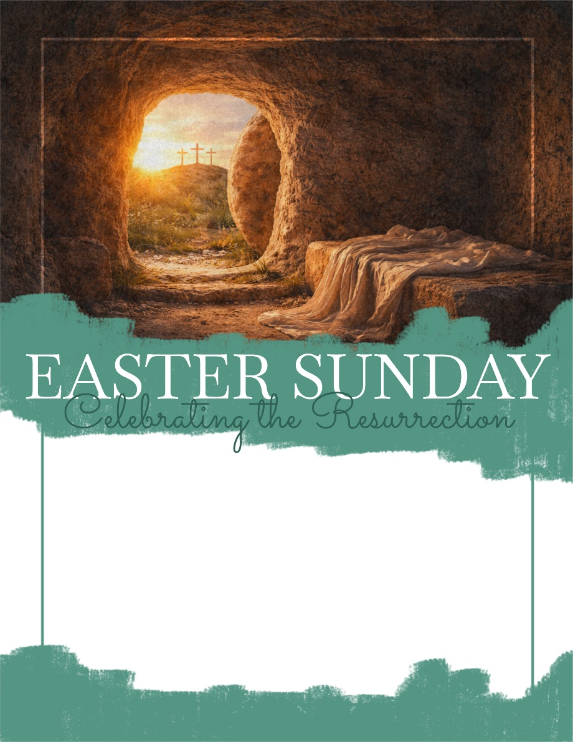

Celebrate a Risen Savior! Sunrise Worship on the front lawn of Broadview Animal Hospital, 134 Ten Rod Road, Rochester, NH at 6:15 AM, followed by the Easter Breakfast back at the church! Sign up in the foyer if you will be at the breakfast! Hot items will be provided, but sign up to bring in fruit, muffins, yogurt and such.

Easter Morning Worship will be 10:45 AM
(No Sunday School on Easter morning)

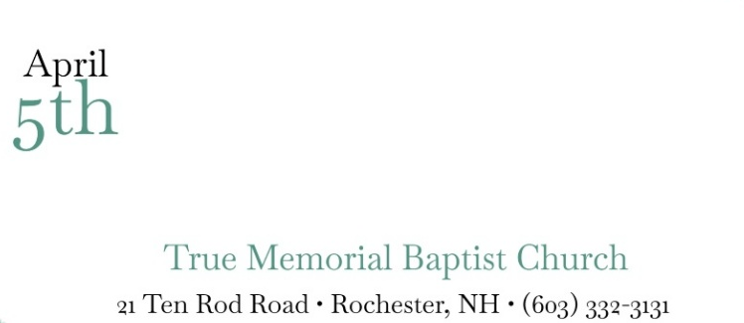



9 to Noon daily!
July 20th -24th
Vacation Bible School

Mark your calendars! Children from four years old through 6th grade are invited!–SonSurf Beach Bash will take kids to an unforgettable beach blast where they will come to know the living Jesus who said: “I am the way, the truth and the life; no one comes to the Father except through me.” (John 14:6).

The Christian Education Committee are planning a great Vacation Bible School for children in our church family and the community. Please let them know as soon if you can help with; teaching, crafts, snacks, help in a class room, decorating the church, and more!

Ginny (603) 781-8028, Laura (603) 957-1503,
Halie (207) 604-8071 or Katie (207) 939-0390

May 18th at 6:30 PM
Leaders Meeting for EVERYONE interested,
(or even thinking about helping!) in reaching children in our community with the Gospel through VBS.

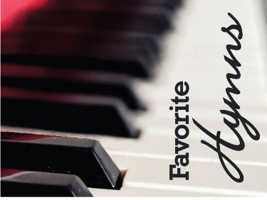
Jenefer has recorded some favorite hymns on the piano (with the help of John H of course). She has thumb drives available of the recording, if you would like a copy, please see Jenefer after the service.


Contact Kasey Hall (603) 970-1517 can help in the Nursery or Children’s Church. If you are not sure what is involved… ask! Someone to teach each week is needed, along with helpers. Everyone working with the children has a background check.

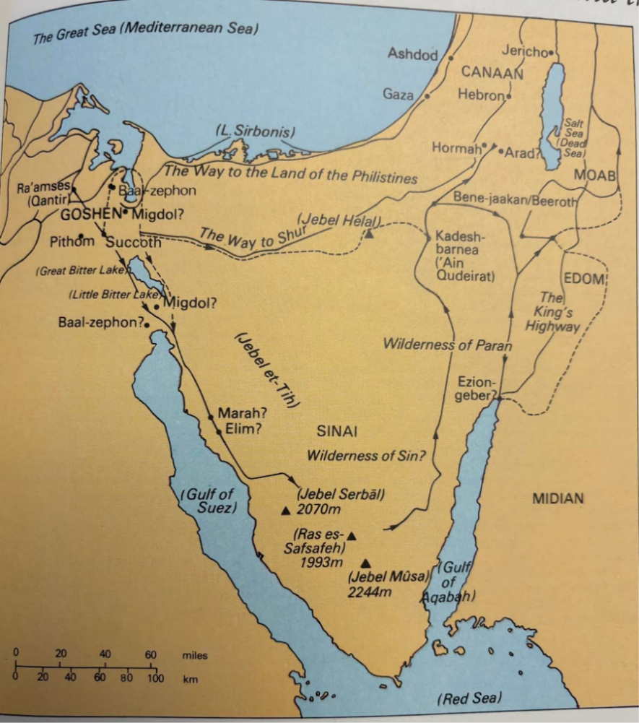
A Stranger
In a Strange Land

