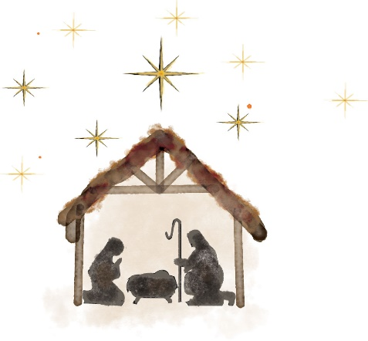

Christmas Morning 2022

Worship in Song
Scripture Reading – Galatians 4:4-6
Prayer of Invocation
Worship in Song
“Name that Christmas Song”
Offering
Hymn # 137 “What Child Is This?” (Verses 1-2)
Message – This Child Is…
Hymn # 137 “What Child Is This?” (Verses 3-4)
Benediction

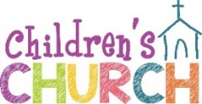

*Children’s Church –AFTER this song, children are dismissed for Children’s Church downstairs. Nursery and toddler rooms are open throughout worship.

TUESDAY! Youth Group!

Teens, 7th grade and up, are invited 6:30-8:30 p.m. Tuesday evenings for dinner, studying God’s Word, worship and games! Teens growing in their faith and reaching others in our community.

Sunday School January 1st

Everyone invited! 9:30 a.m. Children’s classes are downstairs, Teens are in the loft, Young Adults are in the Fellowship Hall and Adults are in the Sanctuary.

Tuesday Morning Prayer – January 3rd

Everyone is invited 9:30 a.m. to a time of prayer, in the church library. Giving thanks and praying for needs in our families, missionaries, our community, nation and worldwide.

Keepers of TRUE Faith

Children from Pre-K through 6th grade are welcome to join in the fun 6:30 -8 p.m. Wednesday evenings! Games, friends, Bible lessons and crafts! Back on January 4th!!!

The first part of the year is focusing on Galatians 5:22-23: “But the fruit of the Spirit is love, joy, peace, patience, kindness, goodness, faithfulness, gentleness, and self-control. Against such things there is no law.”

and Nursery!

We have devoted group of volunteers on a rotating schedule, teaching Children’s Church and staffing the Nursery. Some plan lessons for Children’s Church, Sunday School AND Keepers! But they would like to be able to attend Worship Services more often!

Volunteers are always teamed up, which requires more people. One person teaches, the other helps. If you would like help with Children’s’ Church or in the Nursery, please let someone below know:

Kasey Hall (603) 970-1517
Amber Malone (603) 731-0532
Ginny Weeks (603) 781-8028

Live stream or watch previous sermons online at truememorial.org

Devotionals Daily breads, a daily devotional, and other reading material are on the table in the foyer for you to enjoy or pass along to others.

Missions For more information on the Missions ministry at True, check out the brochure in the pew rack.

True Memorial Baptist Church
Touching Lives with Scripture

Updating Information We use the email in the Church Directory to send out e-mails for urgent prayer requests, and the occasional cancelation. Blue forms are on the table in the foyer to add or update your information. Photos can be texted to Susan at (603) 767-5015 or emailed to secretary@truememorial.org. Use same form to request tithe envelopes. Use envelopes if you would like a receipt at the end of the year and to designate where you would like monies to go: Missions, Current or Special Offering.

The Church Directory is online at InstantChurchDirectory.com and on the table in the foyer. Ask Susan in the office for a printed photo directory. The directories are used by new people trying to get to know each other, consider updating your photos! If your child in the photo is now grown up with children of their own, it might be time!

Temporary Tithe Envelopes are on the table in foyer. Box sets have not arrived yet, sorry for any confusion.

Annual Business Meeting January 10th at 7 p.m.
For all church members! Yes, the Annual Meeting is on a
Tuesday! Discussing and voting on reports, financial matters
and missions. All members are encouraged to come!

All Committees Please contact Bruce Vinciguerra with any budget requests or changes for 2023 as soon as possible and please have the Annual Reports in by January 4th!!! The reports are a great way of letting people know what each committee has been doing this year. And, the first thing many people do when considering going on a committee, is read last years report.
Volunteers for January 1, 2023
Children’s Church: Brian Littlefield and Halie Lewis
Nursery: Kasey Hall and Paula Page

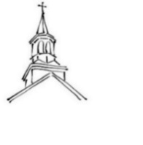
21 Ten Rod Road, Rochester, NH 03866
truememorial.org (603) 332-3131

Christmas Morning 2022
December 25th

Worship in Song – The Band
Scripture Reading – Galatians 4:4-6
Prayer of Invocation
Worship in Song The Band
“Name that Christmas Song” Pastor and Jenefer
Offering
Hymn # 137 “What Child Is This?” (Verses 1-2)
Message – This Child Is…
Hymn # 137 “What Child Is This?” (Verses 3-4)
Benediction

Christmas Morning 2022
December 25th

Worship in Song – The Band
Scripture Reading – Galatians 4:4-6
Prayer of Invocation
Worship in Song The Band
“Name that Christmas Song” Pastor and Jenefer
Offering
Hymn # 137 “What Child Is This?” (Verses 1-2)
Message – This Child Is…
Hymn # 137 “What Child Is This?” (Verses 3-4)
Benediction

Touching Lives with Scripture

True Memorial Baptist Church

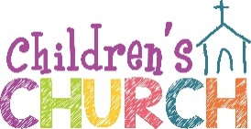

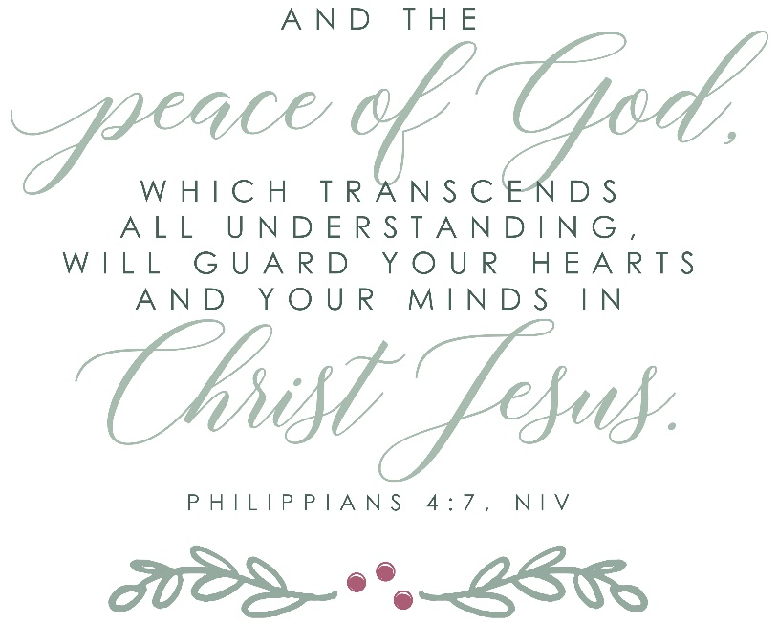

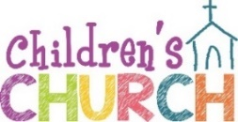

Facing a Task Unfinished

Spreading the Gospel in the U.S and Overseas

Missionaries that serve throughout the world are supported by donations. We as a church family commit each year to donating to help support a number of these missionaries. Gifts are also given in times of need, or for projects throughout the year.

What is a “Faith Promise”? It is people in the church promising a weekly gift designated to Missions. The Missionary Committee then prayerfully commits to helping support missionaries and missions’ organizations for the year 2023 as a church. The amount pledged is whatever God is leading you to give. The amount will only be recorded, if you ask, by way of tithe envelopes for your tax records (ask Susan in the office). Please see the Missions brochure in the pew rack for more information!

We welcome the Spencer Family this morning! More information about their ministry can be found at spencerfamilymusic.com or on the table in the foyer.

If you are looking for a church family, please come back next Sunday. We worship Sunday mornings at 10:45 a.m. with a mix of traditional hymns and contemporary worship songs. Aiming to honor and glorify God in what we do.

Each Sunday Pastor Rick shares a message from God’s Word, with accuracy, clarity and practicality. He brings a depth of understanding of God’s Word from someone who has traveled to Israel, studied the Biblical languages and traditions of Jesus’ time. Pastor has advanced degrees in Theology from Dallas Theological Seminary and his Doctorate from Gordon Conwell Theological Seminary. He is willing to tackle the tough questions.

Trustees Meeting December 20th

November 20, 2022

Operation Christmas Child

You may assemble your own box! Follow the directions in a pamphlet or online, add your donation of $10 for shipping, and Samaritans Purse will send you an update with where your box was delivered.

Include in boxes: toys, personal toiletry items, crayons, pencils, paper, socks and such. Add a “Wow” item! Something like a doll, beading kit, ball or other spectacular item. No war toys, candy or toothpaste.

The message of Salvation in the child’s own language will be added. Boxes are delivered throughout the world to children in need. In many areas a weekly Bible study is then offered.

We will also be assembling boxes here! There is a large collection box in the foyer to drop loose items you would like to donate; crayons, paper, pencils, pencil sharpeners, wash clothes, hair accessories, combs and small toys. Or the much needed “Wow” item!

Snow Shoveling Get Togethers! Contact Bruce Vinciguerra or Nate Savard, be added to the list, and you too will receive a text on when to gather and help shovel the church sidewalks!

In the foyer

On the table in the foyer there is a daily devotional called the Daily Breads, updates from some of our supported missionaries, information on Word Radio and more! Please help yourself!

Keepers of TRUE Faith

Children from Pre-K through 6th grade are welcome to join in the fun 6:30 – 8 PM Wednesday evenings! Games, friends, Bible lessons and crafts!

The first part of the year will be focusing on the
Galatians 5:22-23: “But the fruit of the Spirit is love

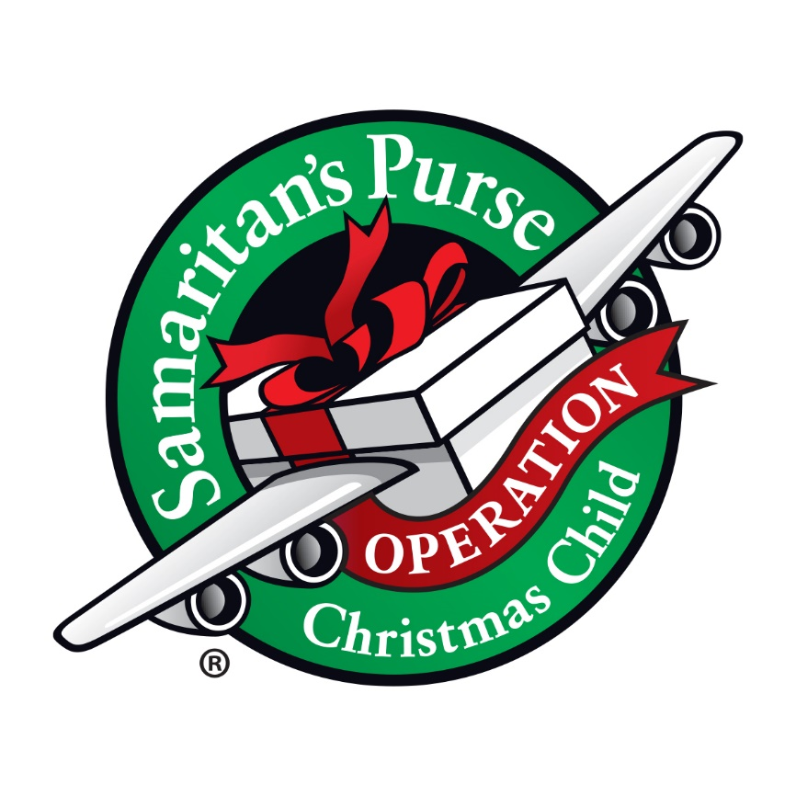

Word Radio 88.7
“The Word
between Sundays

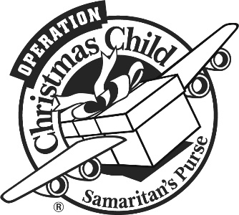

True Memorial Baptist Church

December 19, 2021

Worship in Song
Scripture Reading & Advent Candle Lighting
Prayer of Invocation
Singing of Favorite Christmas Hymns
Offering

Ben Hall - "We Three Kings"
Jack Hall - "O Little Town of Bethlehem"*

Message – This Is No Ordinary Child

Hymn# 151 "Good Christian Men, Rejoice”
Benediction

* Children are dismissed for Children’s Church AFTER this song.

Music Committee

Following the Morning Worship today, in the Library

Missionary Committee

Following the Morning Worship TODAY, in the Office.

Trustees Meeting
6:30 p.m. on Tuesday

Tuesday Morning Prayer

Everyone is invited 9:30 a.m. to an hour of prayer, in the church library.

Youth Group!

All teens, 7th through 12th grade, are invited Tuesday evenings 6:30-8:30 p.m.! Games, Bible lesson and discussion and of course food!

Keepers of TRUE Faith

All children 4 years old thru 6th grade are invited Wednesdays 6:30 –8 p.m.! Crafts, games, snacks and Bible lessons!
We have teachers, but really need two more helpers.
Contact Laura Savard, Kasey Hall or Ginny Weeks if you can help.
No Keepers on December 29th

Sunday School
Every Sunday 9:30 a.m. Children’s classes downstairs, teens in the loft and the adult class in the Sanctuary!

Pass Along Project

We are collecting NEW underwear, socks, hats and gloves/mittens for NH children going into foster care. Many children have only the clothes on their backs when they are placed in a new home. We are working with The Pass Along Project to help provide clothing kits to support those families opening their hearts and homes to help these children. Your help will be greatly appreciated! There is a collection basket in the foyer.

Word Radio 88.7
“The Word between Sundays

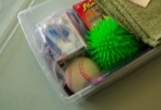

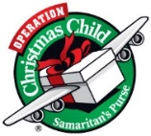

Pastor Richard Lamirande
(603) 332-3131 www.truememorial.org
PO BOX 1001,
21 Ten Rod Road, Rochester, NH 03867

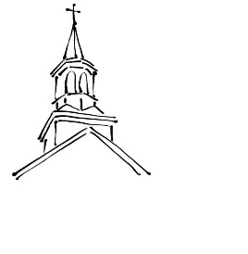

Winter Cancelations

As we enter the winter months there is always the possibility that large winter storms will force us to have to cancel our Sunday services as in years past. In the event of such occurrences, the Pastor and Board of Deacons have implemented a Saturday evening worship service that would take the place of the canceled Sunday services. This will happen only if we foresee that the Sunday service will have to be canceled.

The information for the Sunday service cancelation will continue to appear on the church web-site calendar (truememorial.org) as well as WMUR-Channel 9. In such an event we will meet on Saturday evening at 4 p.m. The purpose behind this is so that we do not have to miss Sunday Worship, and possibly even multiple Sunday Worship services during the winter months as in years past, and we will continue to be able to meet and worship on a weekly basis without interruption.

________________________________________________________________________________________________________________________________________________________________________________________________________________________________________________________________________________________________________________________________________________________________________________________________________________________________________________________________________________________________________________________________________________________________________________________________________________________________________________________________________________________________________________________________________________________________________________________________________________________________________________________________________________________________________________________________________________________________________________________________________________________________________________________________________________________________

December 18, 2022

Worship in Song The Band

Scripture Reading – Hebrews 1:1-3a (NKJV)

“In the past God spoke to our ancestors through the prophets at many times and in various ways, but in these last days he has spoken to us by his Son, whom he appointed heir of all things, and through whom also he made the universe.
The Son is the radiance of God’s glory and the exact representation of his being, sustaining all things by his powerful word.”

Prayer of Invocation

Worship in Song The Band

Singing of Favorite Christmas Hymns

Offering

Ben Hall - "Little Drummer Boy" Piano Solo

Jack Hall - "God Rest Ye Merry Gentlemen"* Piano Solo

Message – It’s Not a Myth

Hymn # 133 “Hark! The Herald Angels Sing”

Benediction

December 18, 2022

Worship in Song The Band

Scripture Reading – Hebrews 1:1-3a (NKJV)

“In the past God spoke to our ancestors through the prophets at many times and in various ways, but in these last days he has spoken to us by his Son, whom he appointed heir of all things, and through whom also he made the universe.
The Son is the radiance of God’s glory and the exact representation of his being, sustaining all things by his powerful word.”

Prayer of Invocation

Worship in Song The Band

Singing of Favorite Christmas Hymns

Offering

Ben Hall - "Little Drummer Boy" Piano Solo

Jack Hall - "God Rest Ye Merry Gentlemen"* Piano Solo

Message – It’s Not a Myth

Hymn # 133 “Hark! The Herald Angels Sing”

Benediction

